Heart


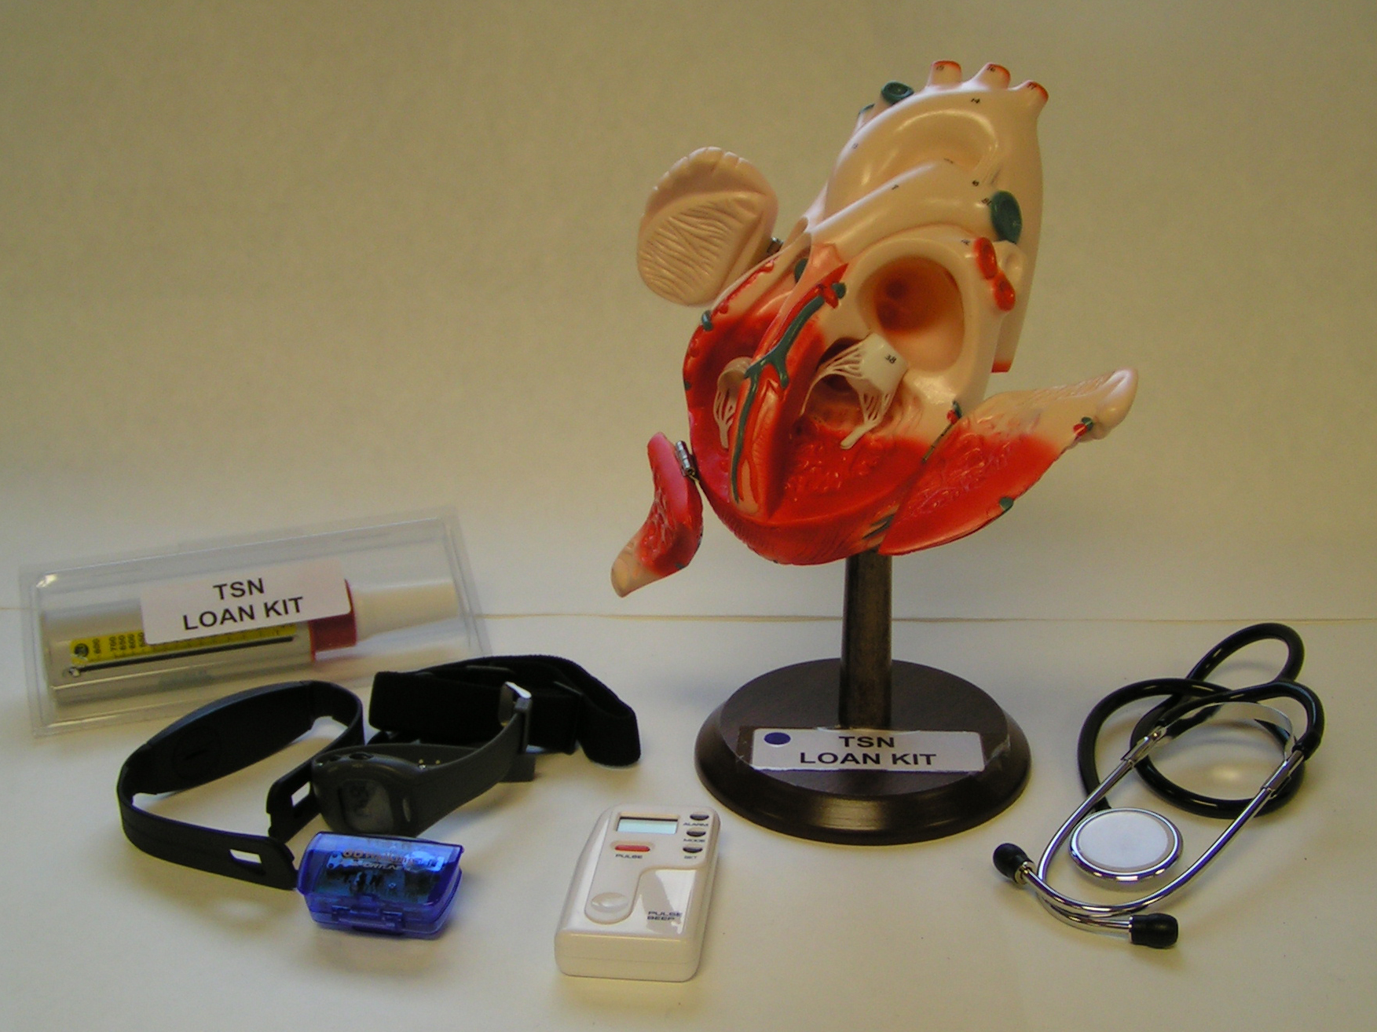

Teachers’ Notes

It should only take about 10 minutes to read these notes. They give some ideas for using the kit.

Additional information is given at the end for interest and further research.

PLEASE READ THIS

Disclaimer

The Teacher Scientist Network (TSN) is pleased to lend its kits to schools, and believes each kit to be suitable for its suggested use. However, we recommend that teachers thoroughly examine and check each kit to make sure it is fit for the purpose intended, making any risk assessment that is appropriate.
The TSN excludes any liability for injury or damage howsoever caused by the use of the kits, is not responsible for the standard of development or safety of any of the products used in the kits, and makes no warranty against errors and omissions in any kit or accompanying material.

Use of Kits

The Teacher Scientist Network is pleased to lend this kit to your school free of charge, and hope that you find it useful.

Please:

- Read the disclaimer and any teachers’ notes.
- Check the kit against the contents list before you take it away.
- Return the kit in a complete and tidy condition ready for the next school
- Don’t keep the kit beyond the date agreed for its return.
- Take care of the equipment.

Although we try to make the kits as robust and child-proof as possible, we might ask you to pay for, or to contribute towards, any breakages or losses other than normal wear and tear.

Thank you for looking after the kit.
Contents

Page
Contents of kit 5
Introduction 6
Some ideas for use
- Testing heart rate before and after exercise 6
- Listening to the heart using a stethoscope 7
- Measuring lung peak flow 8
Additional background information
- The heart 9
- The blood 9
- How to use the chest heart rate monitors 10
- How to use the finger pulse rate monitors 11
- How to use the peak flow meter 13
Appendix
Key to the giant hands-on heart

Contents of kit

1 giant hands-on model heart on stand

8 Run Tec heart rate monitors: elasticated strap
chest band transmitter
wrist receiver
laminated instructions

1 peak flow meter + disposable mouthpieces

2 stethoscopes

1 finger pulse meter

1 pedometer + instruction booklet

basic wipes

2 posters: The Heart
The Story of Blood

1 set of Teacher’s Notes

Introduction

The model heart is 2x actual size. As a general rule a person’s heart is about the same size as their clenched fist. It is robust and easy to see inside. Details are given in the appendix.

Ideas for use:

- Testing heart rate before and after exercise

The chest heart rate monitors and the finger pulse can both be used to determine the pulse/heart rate. The fingertip pulse meter is often easier to use for smaller children (the chest monitors need to be tight to work properly).

Take the rest pulse rate before exercise and again after. There should be a noticeable difference after 10 minutes of running/ jumping/ hopping or even brisk walking.

A measure of a person’s fitness is the time taken to return to the rest heart rate after exercise. The quicker it returns to normal, the fitter you are.

Blood is pumped faster to all parts of the body during exercise as each cell burns food faster to supply energy faster. More oxygen is needed in each cell to do that. This means that your body needs to move more air in and out of the lungs quickly. After exercise the breaths are quicker. Breathing should return to normal after resting. The quicker it does, the fitter you are.

Details of how to use the chest heart rate monitors are on p9, and the finger pulse rate monitors on p10.

- Listening to the heart using a stethoscope

Put both stethoscope earpieces in and hold the hollow end piece gently against the chest over your heart (it is usually on the left hand side of the body). The stethoscopes can also be used to listen to your pulse points in the wrist or throat.

Each heartbeat has two parts. This is because the heart works as two separate pumps – pumping blood from the heart to the lungs under low pressure and from the heart to all parts of the body under high pressure.

Use the stethoscopes to listen to the way the heart beats before and after exercise. It is much faster after! It beats faster because the blood carrying oxygen to the cells needs to arrive faster to replace energy used up during exercise.

A measure of a person’s fitness is the time taken to return to the rest heart rate after exercise. The quicker it returns to normal, the fitter you are.

The earpieces should be wiped clean with a mild disinfectant (such as a babywipe) between each person.

- Measuring lung peak flow

Peak flow is a measure of how fast someone can blow air out of his/her lungs. It measures how wide the airways in their lungs are and how well air is moving through them.

Peak flow meters are sometimes used to monitor asthma sufferers. Their lung capacity often falls before symptoms such as coughs and shortness of breath are obvious.

Lung capacity is linked to body weight and fitness. The larger you are, the larger your lungs tend to be. The fitter you are, the more efficient you are at getting air in and out of your lungs.

The peak flow meter comes with disposable cardboard tubes to fit over the mouthpiece. Use one tube per person and then throw it away.

More detailed instructions about how to use the meter are on p12.

Further Background Information
1. The heart

An adult male’s heart weighs about 300g. It beats about 70 times each minute forcing through about 5 litres of blood per minute. Every day, the heart moves about 4 tonnes of blood around the body through a network of tubes nearly 90 000km long in an adult. If it stops, so will you. The brain needs a lot of blood – nearly 10% of the heart’s output goes to the brain.

The heart acts as two separate pumps. One is a low-pressure pump sending blood to the lungs where it picks up oxygen. The other is a high-pressure pump that sends this freshly oxygenated blood to every other part of the body. They pump together. Their outputs are accurately matched and there is no shortage or excess of blood anywhere in the cardio-vascular system – the heart, arteries and veins.

2. The blood

Blood carries oxygen and nutrients to all parts of the body. It also has other roles – in defending the body against microbes and removing waste products from cells, for example. Human blood is mainly salty water. It gets its red colour from the iron in haemoglobin, part of the red corpuscles. These are disc-shaped cells about 0.007mm across that are renewed every 4 months. The red corpuscles use the haemoglobin to carry oxygen from the lungs to every cell in the body. Oxygenated blood is bright red, de-oxygenated blood is darker and bluish.

An adult contains about 85 millilitres of blood per kilogram – roughly 9% of the body’s weight.
3. How to use the chest heart monitors

NB
- get the transmitter snug against the chest and moisten with water before use.
- try to keep at least 1m between each transmitters to prevent interference.
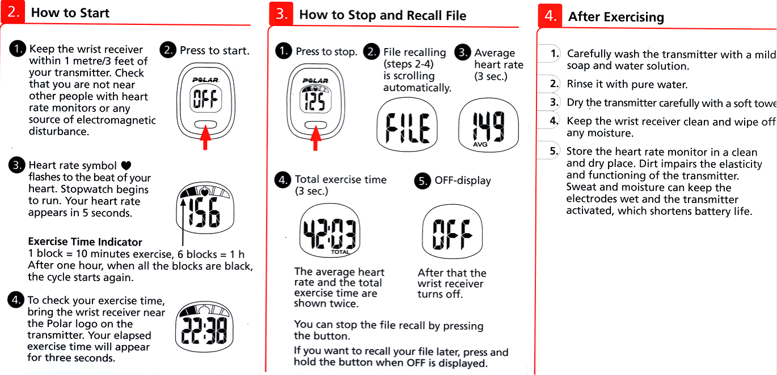
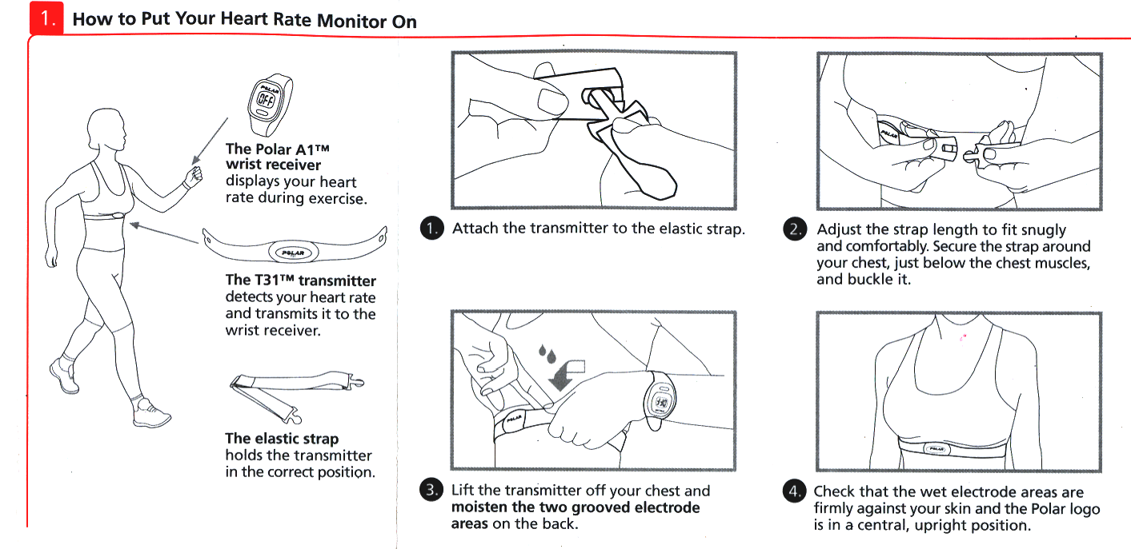
4. How to use the finger pulse rate monitors

SENSOR
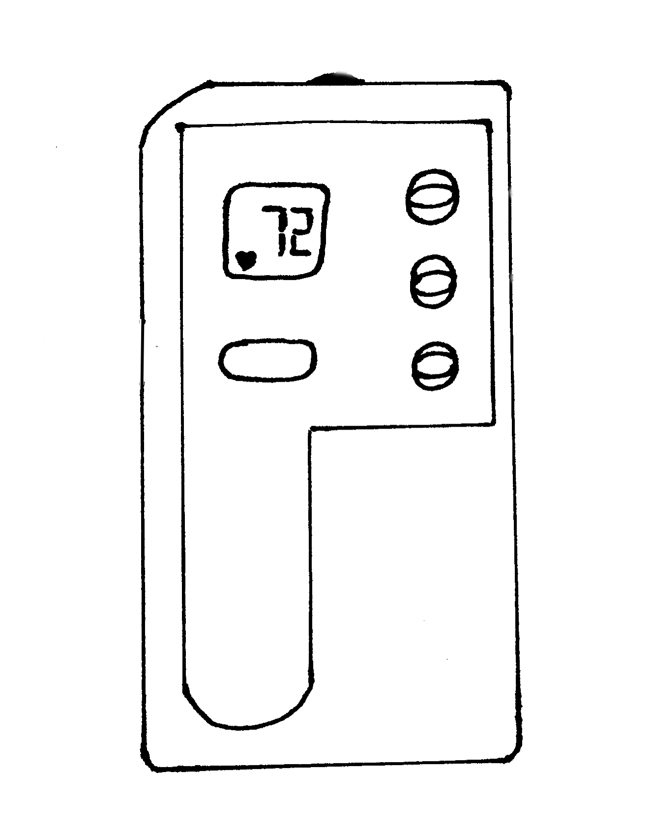

ALARM

MODE

SET

PULSE
PULSE

To measure pulse rate
- Hold the unit in your left hand then touch your fingertip to the sensor. Do not press hard on the sensor.
- Press the PULSE button by your thumb to turn the display into PULSE mode.
- The display will first show “_ _ _ _”then “0” then “♥”. The heart symbol means that the unit is ready.
- You will hear a ‘beep beep’ sound and the “♥” symbol will flash at the same speed as your heart beating.
- After 4 seconds, your pulse rate will be picked up and shown on the display.
- After 45 seconds the “♥” symbol will stop flashing and your average pulse rate will be displayed flashing continuously.
- The pulse rate will flash for one minute or you can press once on the PULSE button to shift to TIME mode.
- If your fingertip is not over the sensor correctly, the sound will beep irregularly. If this happens, reposition fingertip.
- The sensor is very sensitive to light and heat. Do not use in direct sunlight or high temperatures or it will give the wrong pulse reading.
- It is not waterproof. Keep away from water or liquid.

- How to use the peak flow meters

1
Insert the mouthpiece into the meter, if not already fitted. Ensure the pointer is set at zero (L/MIN position)
2
Hold the peak flow meter so that your fingers are clear of the scale and slot. Do not obstruct the holes at the end.
3
Stand up if possible, place the meter in the mouth and hold horizontally, closing the lips around the disposable cardboard mouthpiece, then blow as hard and as fast as you can.
4
Note the number on the scale indicated by the pointer
5
Return the pointer to zero (L/MIN position) and repeat the procedure twice more to obtain 3 readings.
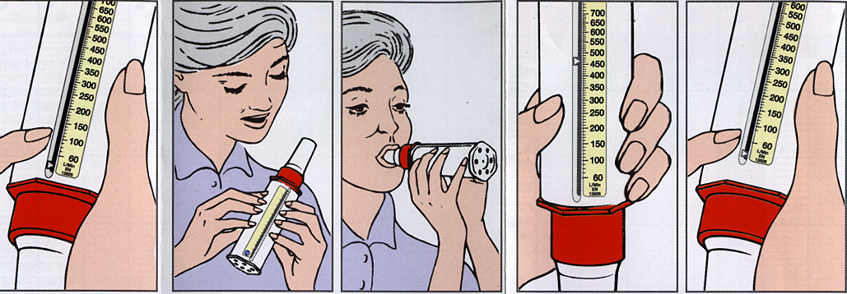

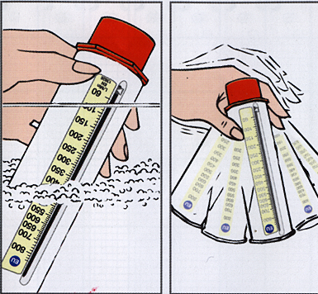
Cleaning the peak flow meter

Immerse in warm (but not hot) mild detergent solution for 2-3 minutes (max 5 mins). Agitate the meter to ensure thorough cleaning.
Rinse in clean warm water and shake gently to remove any excess water. Allow to dry thoroughly before using again.

